COVID-19 Data Visualization using Python

**Table of Contents:**

* **Introduction**
* **Aim**
* **Methodology & Dataset Description**
* **Implementation**
* **Results (Screenshot)**
* **Conclusion**
* **Certificate**

## **1. Introduction**

The COVID-19 pandemic has highlighted the importance of understanding and visualizing data trends for effective decision-making and public awareness. This project aims to leverage Python for creating insightful data visualizations that track the virus's progression and impact across various regions. By presenting this data in a visual format, we aim to help stakeholders grasp the situation better and respond more effectively.

## **2. Aim**

The primary goal of this project is to develop interactive visualizations that effectively communicate key COVID-19 metrics such as infection rates, mortality rates, and vaccination progress. By visualizing data trends, the project seeks to enhance understanding and facilitate data-driven decision-making. Ultimately, it aims to serve as a tool for public health officials, researchers, and the general public.

## **3. Methodology & Dataset Description**

To achieve this aim, the project utilizes Python libraries such as Pandas, Matplotlib, and Plotly for data manipulation and visualization. The dataset includes global COVID-19 statistics sourced from reputable repositories such as Johns Hopkins University and governmental health agencies. The methodology involves:

**Data Preprocessing:** Cleaning and formatting raw COVID-19 data to ensure accuracy and consistency.

**Exploratory Data Analysis (EDA):** Analyzing trends, patterns, and correlations within the dataset to identify key insights.

**Visualization**: Generating interactive plots and graphs using Matplotlib and Plotly to visualize infection rates, mortality rates, and vaccination progress over time and across different geographical locations.

## **4. Implementation**

The implementation phase includes the following steps:

**Data Preprocessing:**

* Importing necessary libraries and loading the dataset.
* Cleaning the data by handling missing values and ensuring consistent formats.

**Exploratory Data Analysis (EDA):**

* Generating summary statistics to understand the dataset.
* Visualizing key metrics with basic plots to identify trends and patterns over time and across different regions.

**Visualization:**

* Creating interactive visualizations using Matplotlib and Plotly, including:
* Line charts to show daily infection rates over time.
* Bar charts for comparing vaccination progress across regions.
* Heatmaps to visualize case density in various areas.

## **5. Results (Screenshot)**

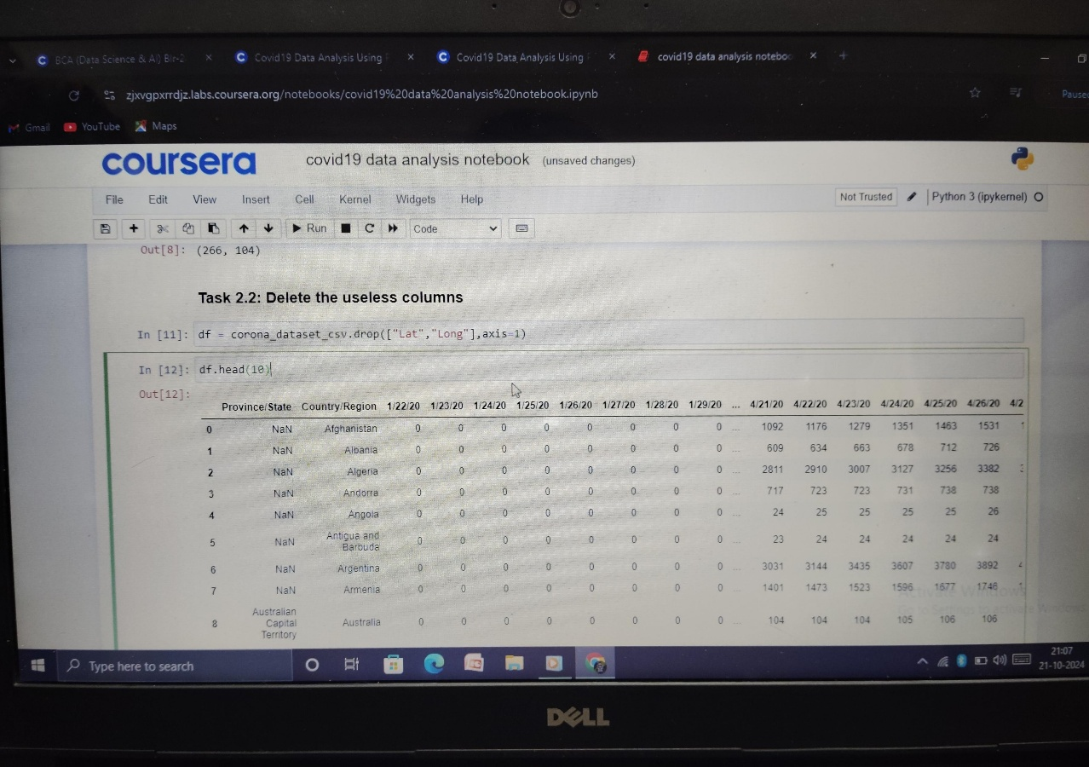***The provided image shows a Jupyter Notebook open, with the COVID-19 data analysis notebook selected. The first code cell output suggests that the dataset contains information about COVID-19 cases by province, country, and date. This suggests that the notebook is likely analyzing trends in infection rates, mortality rates, and vaccination progress over time and across different regions.***

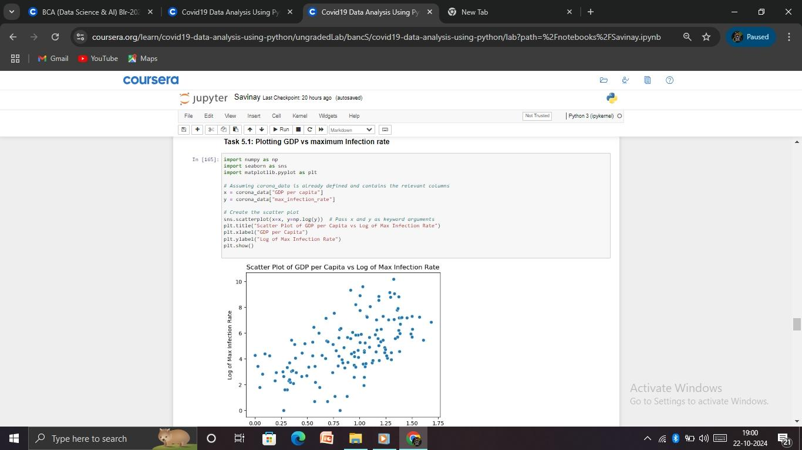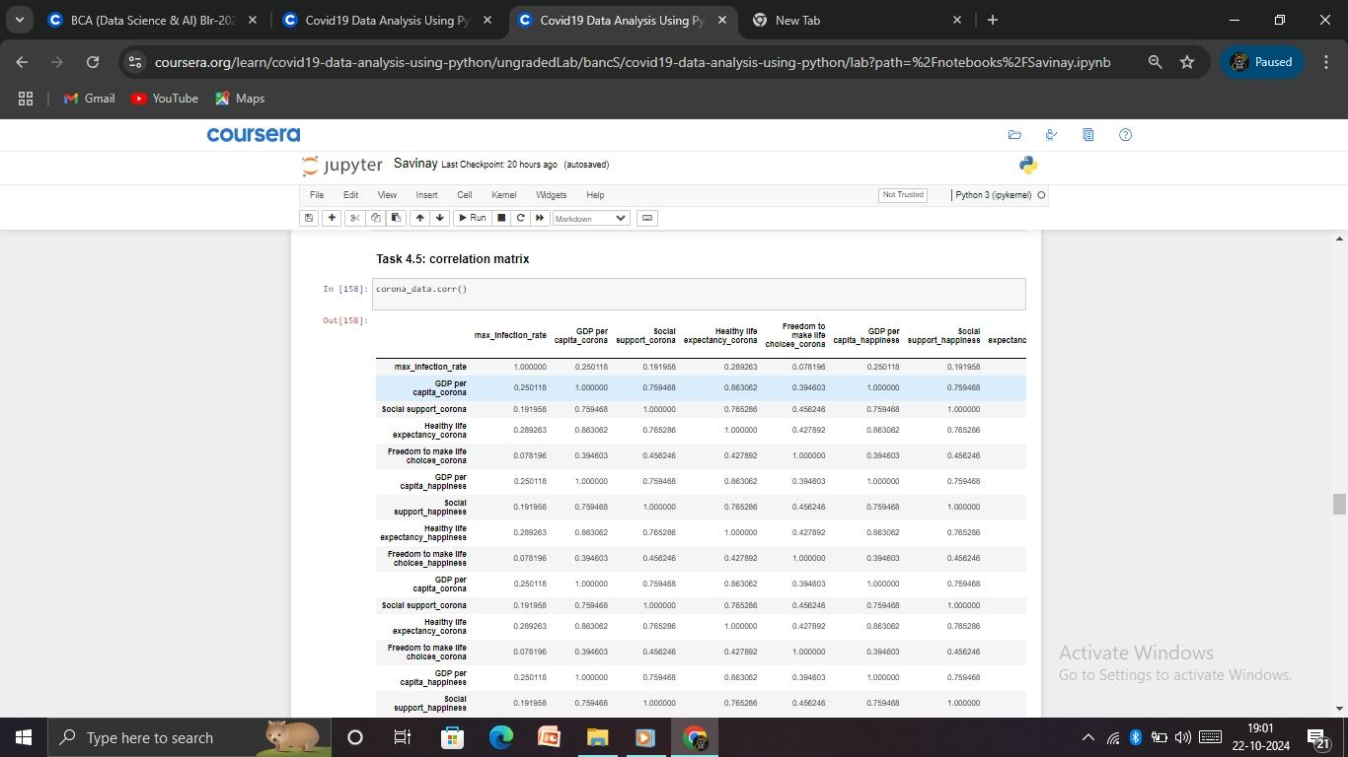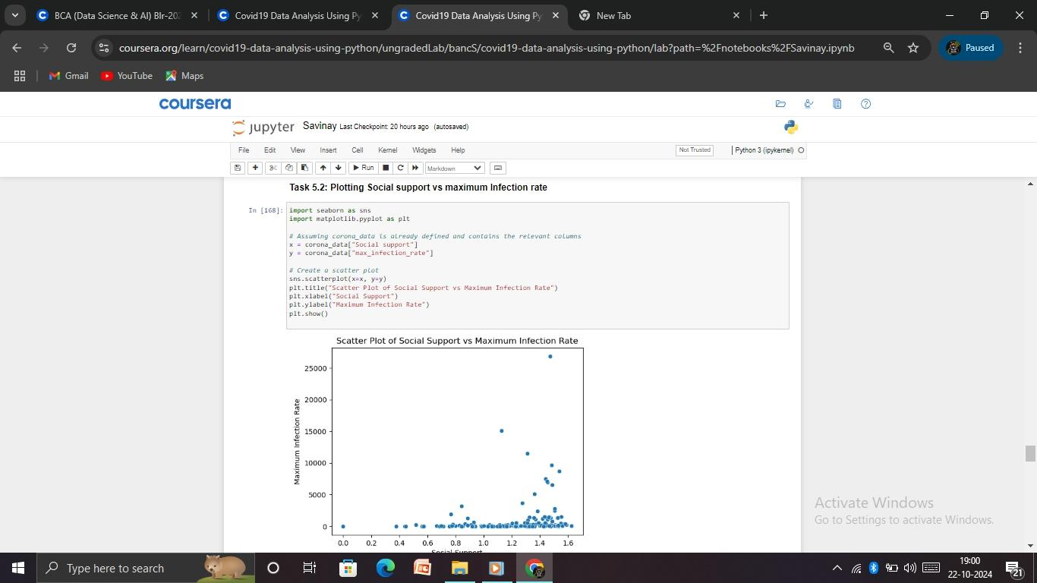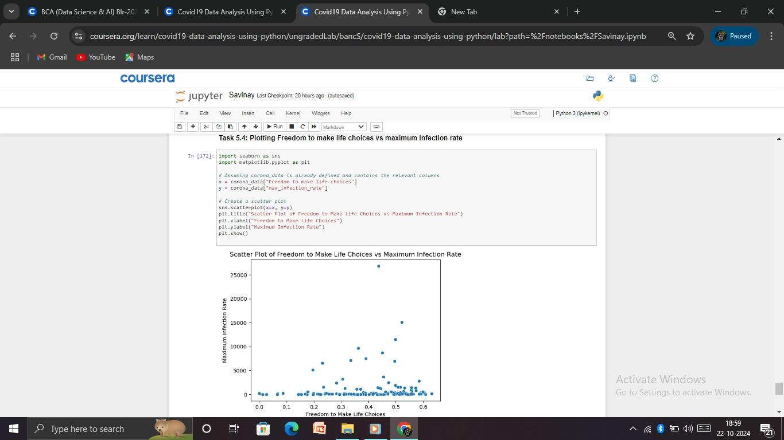

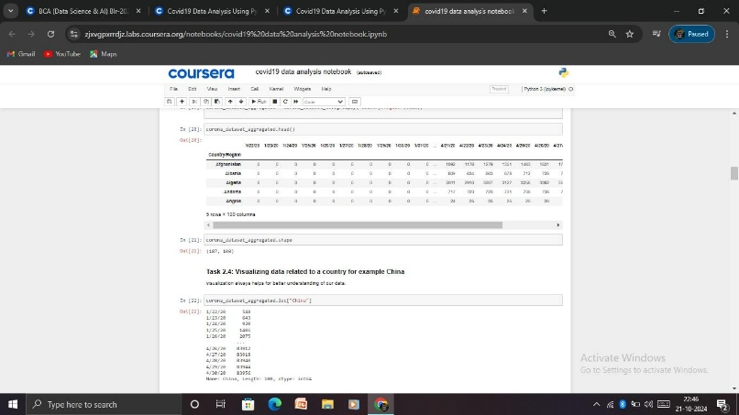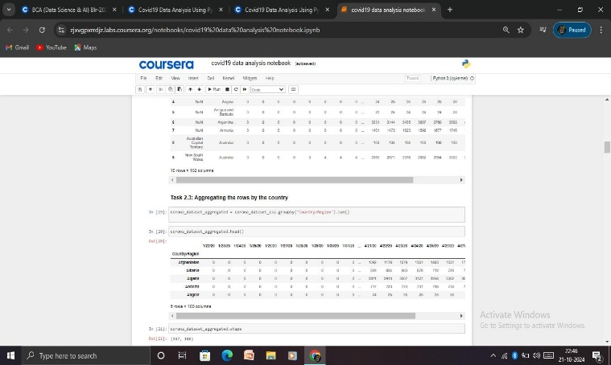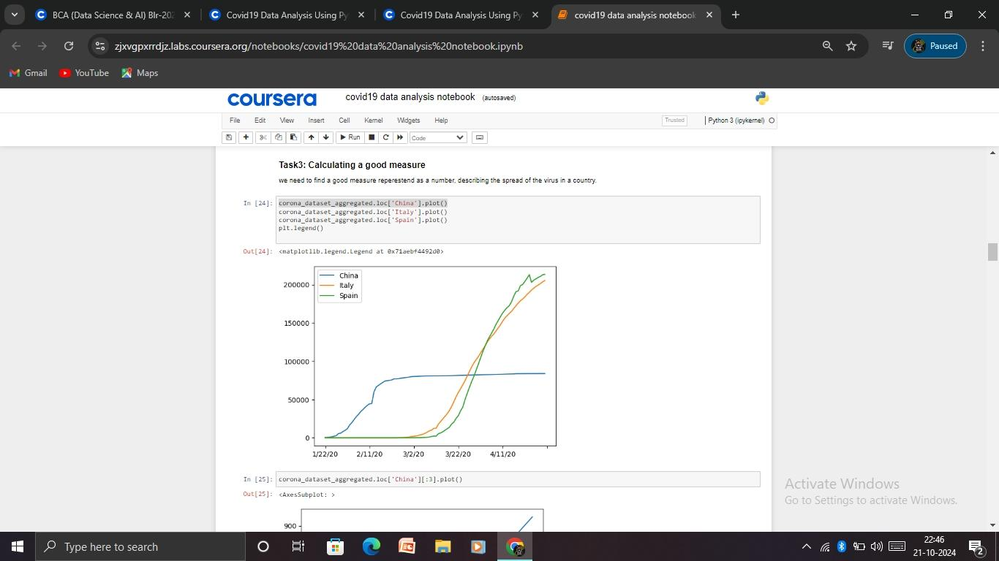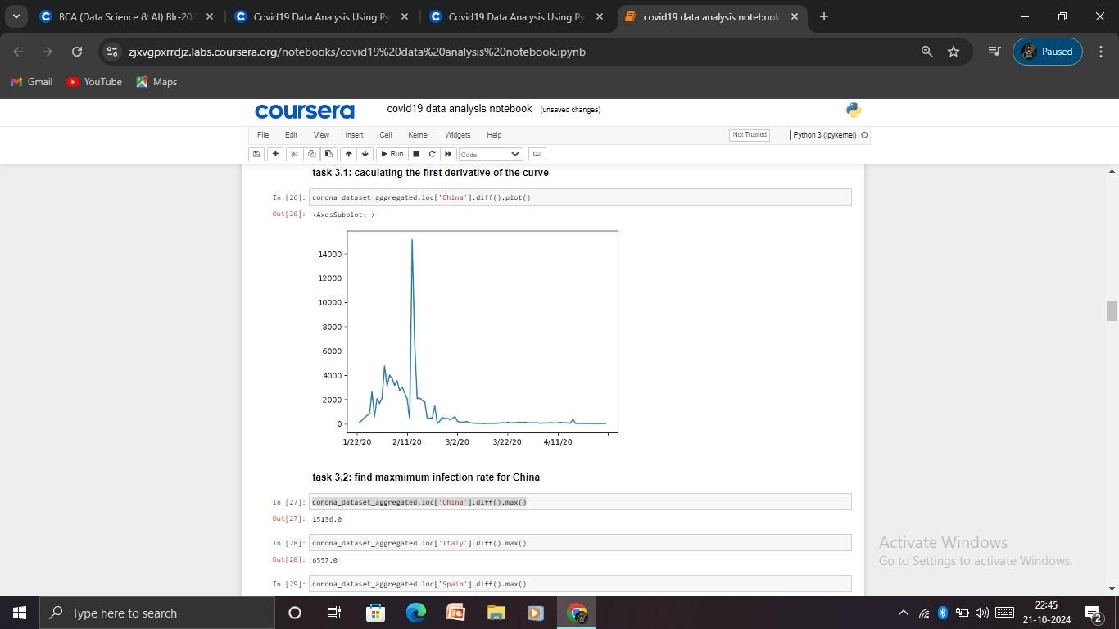

## **6. Conclusion**

Through Python-based data visualization techniques, this project successfully illustrates the evolving landscape of the COVID-19 pandemic. The visualizations generated provide valuable insights into the spread of the virus, its impact on different regions, and the effectiveness of mitigation strategies. By making data accessible and interpretable, this project contributes to public understanding and decision-making in combating COVID-19. Future work could involve real-time data updates and the incorporation of additional datasets for more comprehensive analysis.

## **7. Certificate**

*Upon completion of this project, a certificate of accomplishment is awarded, highlighting proficiency in COVID-19 data visualization using Python and demonstrating practical skills in data science and visualization.* 